DATA DICTIONARY

* **Processes:**

**Student Login System:**

Description: This process lead student to enter the website. Student enters its credentials given by the university/college. After logging in student can access different processes.

In-Flow: Email ID and password from student.

Out-Flow: Authentication.

**Staff Login System:**

Description: This process lead admin/warden/attendant to enter the website. Staff member enters its credentials given by the university/college. After logging in student can access different processes.

In-Flow: Email ID and password from staff.

Out-Flow: Authentication.

**Update System:**

Description: Student and Staff both can update their profile such as phone number, profile photo etc using this system. Several protocols need to be followed to update profile.

In-Flow: Changes in the profile by staff and student.

Out-Flow: Updated Profile to studentDB and staffDB.

**Announcement System:**

Description: Announcements can be posted or updated by staff for students and students can check these announcements on their dashboards.

In-Flow: Announcements from admin/warden/attendant.

Out-Flow: Showing announcements to students.

**Complaint System:**

Description: Students can post or update their complaints that they want to complain to staff. Staff can see the complaints that are referred to them. Also staff can respond to complaints.

In-Flow: Complaints by students.

Complaint’s response by admin/warden/attendant.

Out-Flow: Complaints to staff.

Complaint’s response to students.

**Room System:**

Description: In this system warden/attendant can set room allotment criteria and also can deallocate a room and they can upload list of rooms that have been allocated, while the admin can download that list. Student can select rooms that are available to him/her plus can also download the list.

In-Flow: Allotment criteria, Deallocation order and final list of rooms from warden/admin.

* Select room request and status check request from student
* Get list request from admin

Out-Flow: Status response to student.

Final list to admin.

**Student Forgot System:**

Description: Student can change their password if they forgot in this system. Student have to add their email address then an otp will be send to the registered mobile number and after verifying otp the system requests for new password. And after validation it update the password in database.

In-Flow: Email address and new password from student.

Out-Flow: Updates new password to database.

**Staff Forgot System:**

Description: Staff can change their password if they forgot in this system. Staff have to add their email address then an otp will be send to the registered mobile number and after verifying otp the system requests for new password. And after validation it update the password in database.

In-Flow: Email address and new password from staff.

Out-Flow: Updates new password to database.

DATA FLOWS

**Login Credentials:**

Description: Email Id and password for login to website by student or staff.

Flow: From student to student login system and from admin/warden/attendant to staff login system.

Data structure: studentDB, staffDB.

**Select Room:**

Description: Room number selected by student such that the room selected will be allocated to that student.

Flow: From student to room system.

Data Structure: roomsDB.

**Selection Response:**

Description: Response by system to student about their room selection.

Flow: From room system to student.

Data Structure: roomsDB.

**Complaints:**

Description: Complaints posted or updated by student that reach out to specific member from staff.

Flow: From students to complaint system and From complaint system to admin/warden/attendant.

Data Structure: complaintsDB.

**Complaint’s Response:**

Description: Response by the Faculty to student’s complaint.

Flow: From admin/warden/attendant to complaint system.

From complaint system to student.

Data Structure: complaintsDB.

**Update Profile:**

Description: Updating of user’s information such as phone number, profile photo etc.

Flow: From students and admin/warden/attendant to update system.

Data Structure: studentDB, staffDB.

**Check Status:**

Description: Checking room number by students.

Flow: From students to room system.

Data Structure: roomsDB.

**Status Response:**

Description: Response to check status command.

Flow: From room system to student.

Data Structure: roomsDB.

**Announcement:**

Description: Announcements for students posted by staff(admin/warden/attendant).

Flow: From admin/warden/attendant to announcement system.

From announcement system to students.

Data Structure: announcementDB.

**Room Things:**

Description: This consist of allotment criteria of room, Plus Deallocation of a room that is emptying a room provided by a member of staff.

Flow: From admin/warden/attendant to room system.

Data Structure: roomsDB.

**Upload List:**

Description: Final list of rooms allotted uploaded by either warden or attendant for students to check their respective allotted rooms.

Flow: From warden/attendant to room system.

Data Structure:

**Request List:**

Description: List requested by admin to check whether the rooms are filled as the way it decided.

Flow: From admin to room system.

Data Structure:

**Get List:**

Description: Final list downloaded by admin.

Flow: From room system to admin.

Data Structure:

**Email:**

Description: Email id of user to change their password as they forgot the older one.

Flow: From student to Student forgot system.

From admin/warden/attendant to Staff forgot system.

Data Structure: studentDB, staffDB.

**New Password:**

Description: New password to change their forgotten one by student, admin/warden/attendant.

Flow: From student, admin/warden/attendant to their respective forgot systems.

Data Structure: studentDB, staffDB.

DATA STRUCTURES

* studentDB:

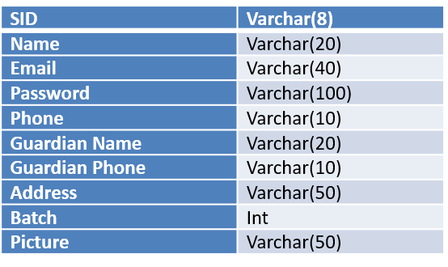

* staffDB:

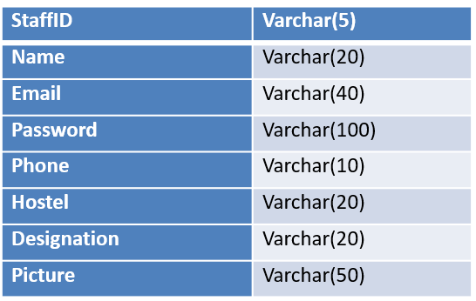

* roomsDB:

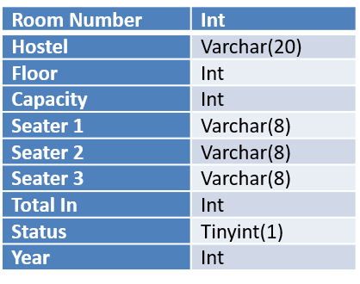

* announcementDB:

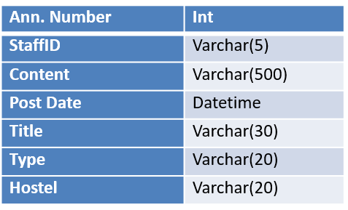

* complaintDB:

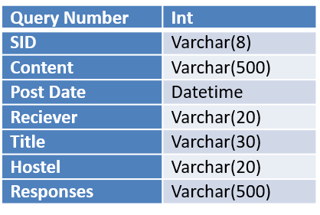

**SAHIL SINGLA(18103017)**

**MANAV SINGLA(18103065)**